**Computer**

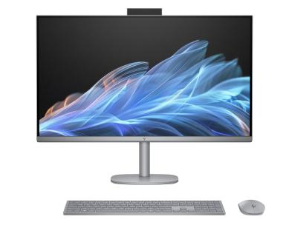A Computer is a machine or deviced

That process, calcculation and operation

Based on instructions provided by a

Software or hardware program .

It has the ability accept data( input)

Process it and the produce output

Modern computer are electronic device used for a

Verity of purpose ranging from browsing the web writing document,editing videos, creating application ‘s

Playing video game etc.

Computer has two parts

1. Hardware
2. Software

**Hardware**

**Computer hardware** refers to the **physical components** of a computer system.

These are the parts you can **see, touch, and replace** like the keyboard, monitor, mouse, hard drive, graphic card, sound card ,speaker and motherboard.

Hardware has four parts

1. Input device
2. Output device
3. Processor
4. Storage devices